How to Troubleshoot the Queue
  - By John Oliver

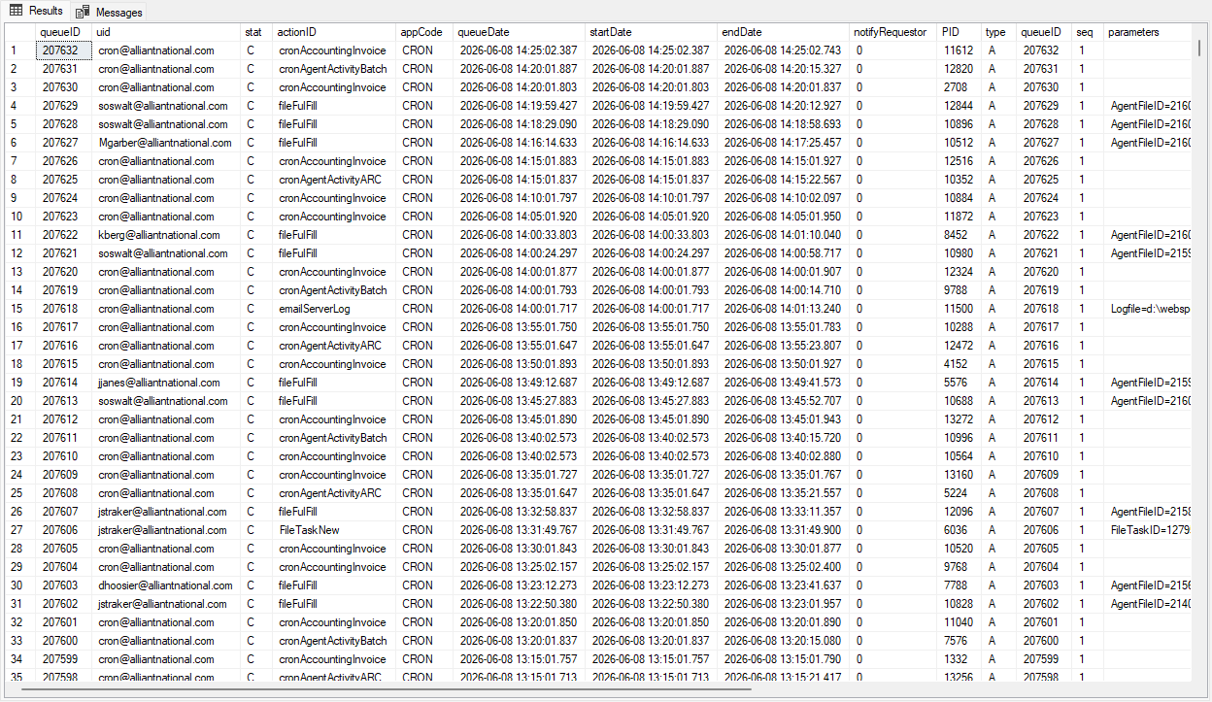

Contents
Prerequisites 3
Resetting a Queue Item 4
Stalled Action 5
Restarting the Queue 7
Files 9

Prerequisites
- Access to edit data in the Compass Production database, COMPASS_PROD.
- Administrative access to the server Johnson.

Resetting a Queue Item
- Run the SQL file against the Compass Production database.
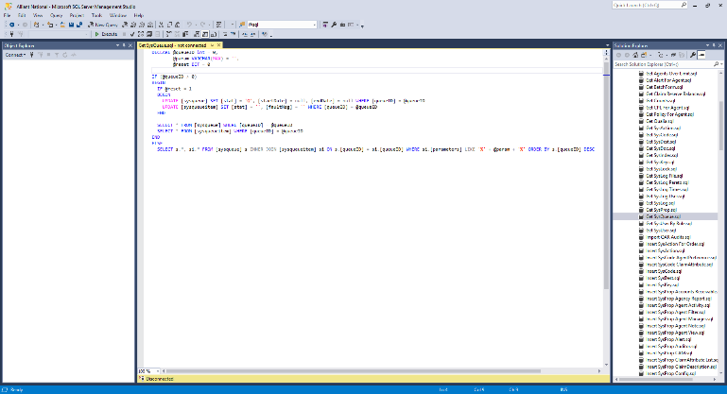  Figure 1: The Get SysQueue query. | 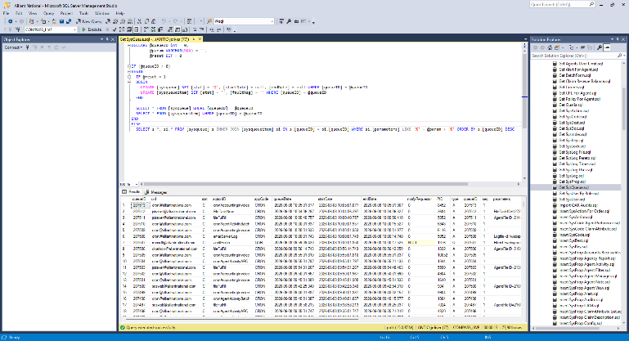  Figure 2:The result of the query.
- Find the queue item that requires restarting. If necessary, the variable @param can be used to filter the list.
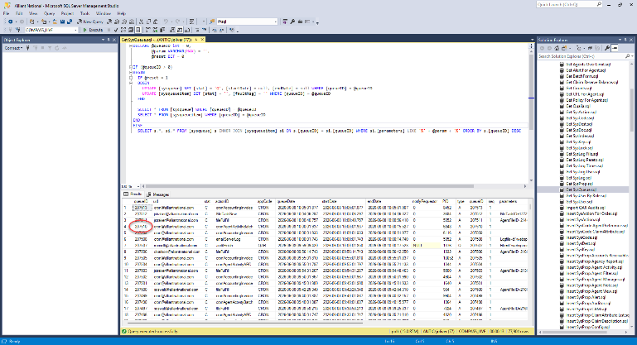  Figure 3: Copy the Queue ID of the item that needs to be restarted. | 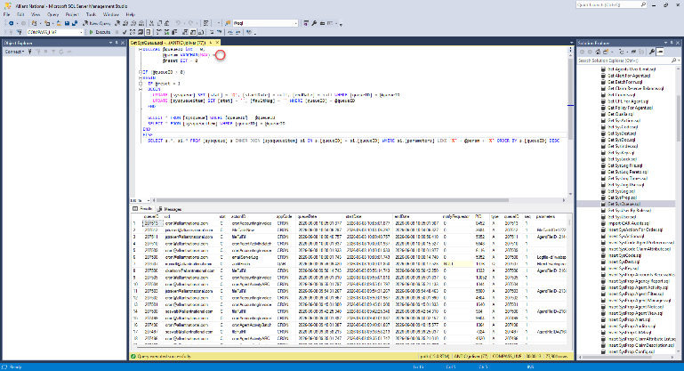  Figure 4: If needed, use the variable @param.
- Place the ID of the queue item in the variable @queueID, set the variable @reset to 1, and execute the query.
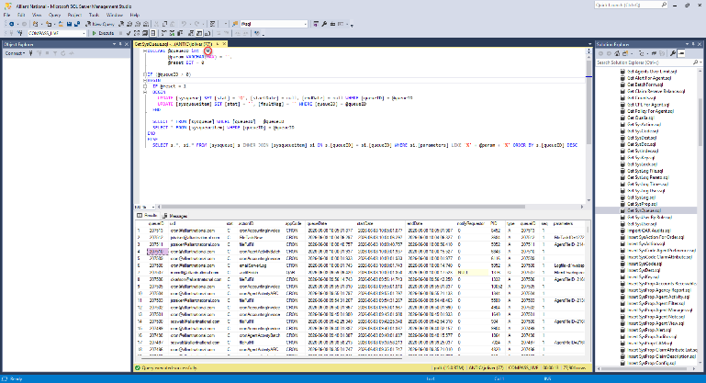  Figure 5: Set the variable @queueID to the copied value… | 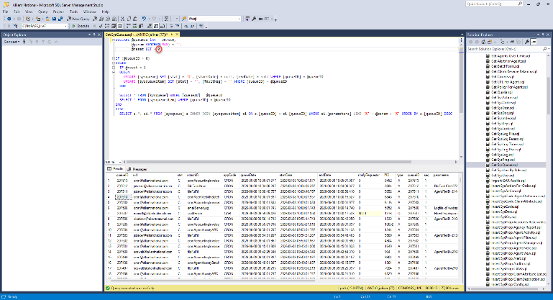  Figure 6: …and the variable @reset to 1.

Stalled Action
- Logon to Johnson.
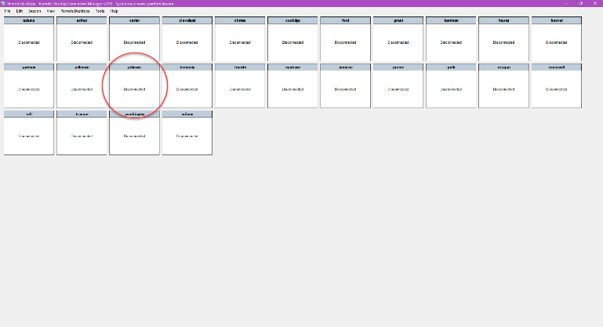  Figure 7: Double click the Johnson server. | 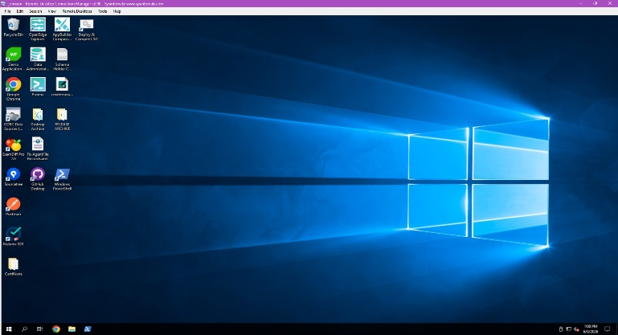  Figure 8: The Johnson server.
- Open File Explorer and click log under the Quick access menu.
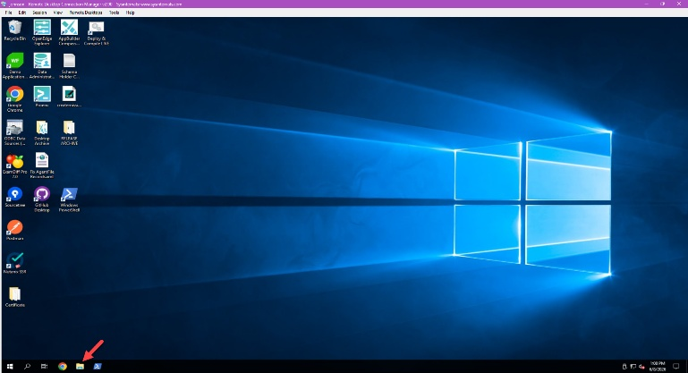  Figure 9: Open File Explorer… | 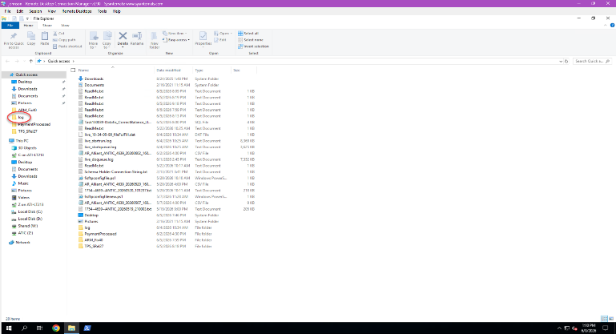  Figure 10: …and navigate to the log folder.
- Sort the list by Type, if not done, and determine if any DAT files are present for the action.
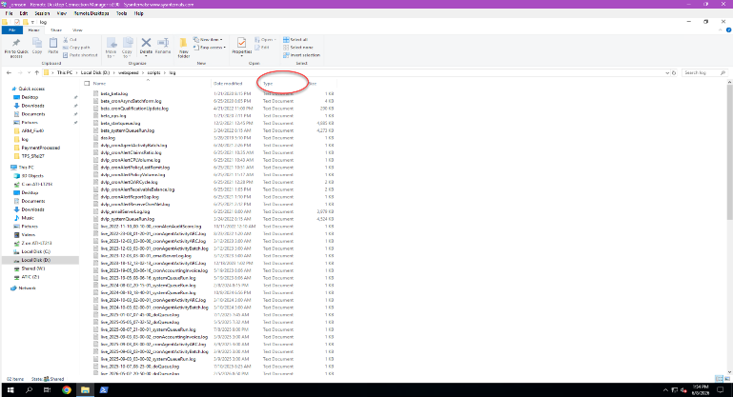  Figure 11: Sort by Type… | 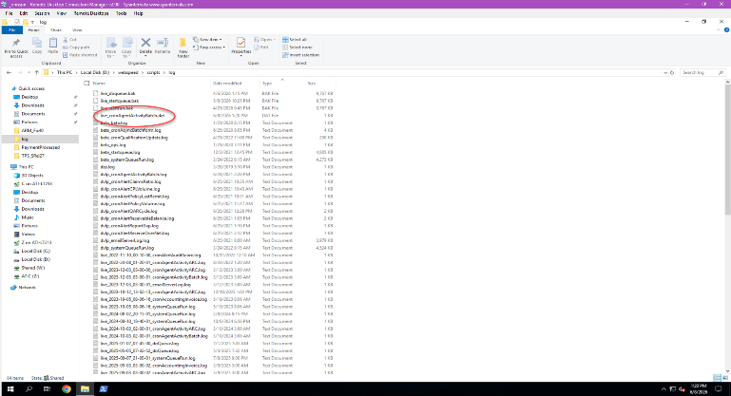  Figure 12: …to make it easier to determine if a DAT file is present

- If there is a DAT file present, delete it to allow the action to run the next time the queue runs.
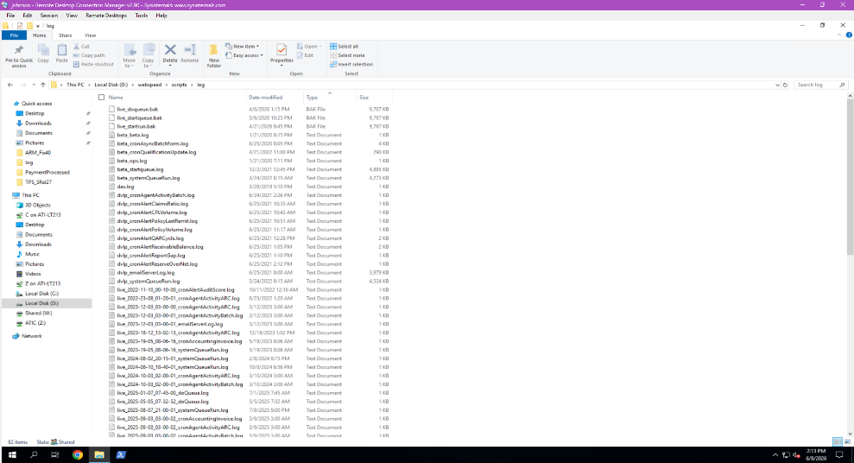
Figure 13: Delete the file to have the action run.

Restarting the Queue
- Logon to Johnson.
  Figure 14: Double click the Johnson server. |   Figure 15: The Johnson server.
- Search for the word task and open the application Task Scheduler.
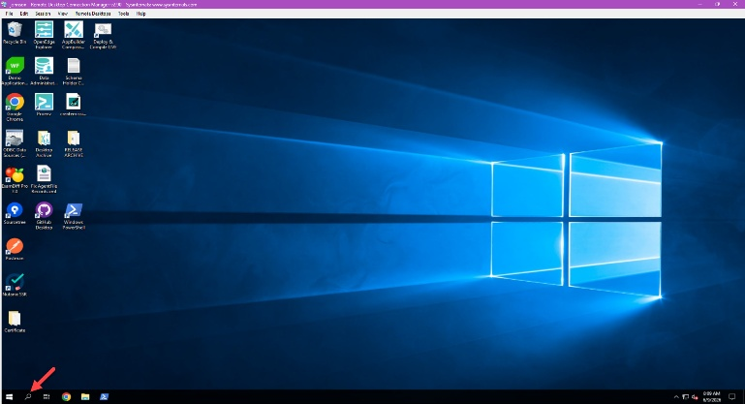  Figure 16: Search for the word task… | 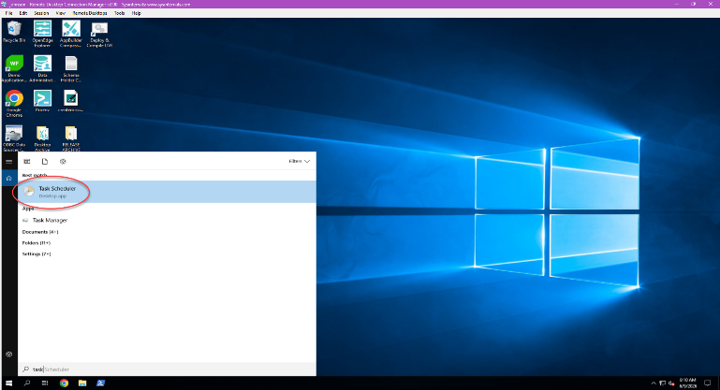  Figure 17: …and click on the Task Scheduler application.
- Expand the Compass folder (under the root folder) and click on the Report Queue subfolder.
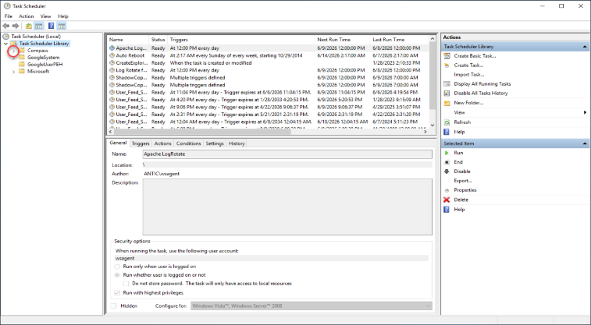  Figure 18: Expand the Compass folder… | 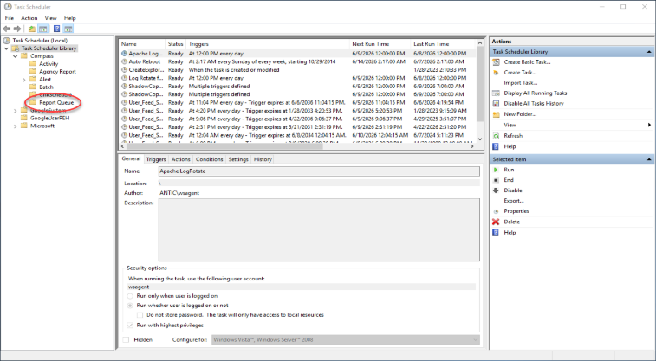  Figure 19: …and click the Report Queue subfolder.

- Double click on the Report Queue task and click on the Triggers tab.
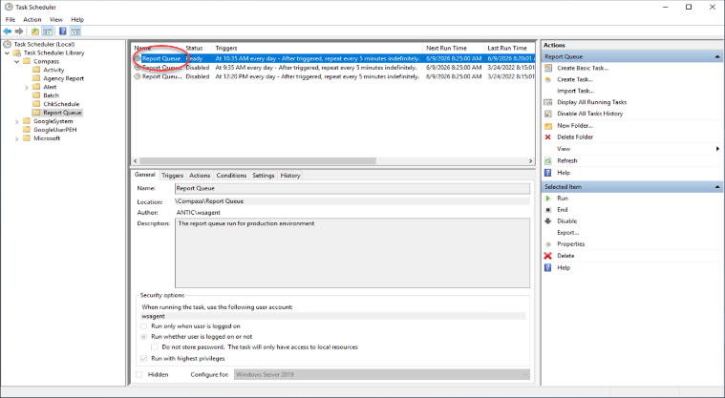  Figure 20: Double click the task with the Status of Ready… | 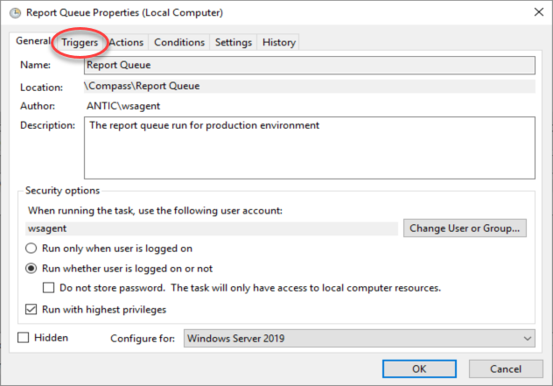  Figure 21: …and click on the Triggers tab.
- Double click on the Daily trigger and set the Start date and time to somewhere in the future.
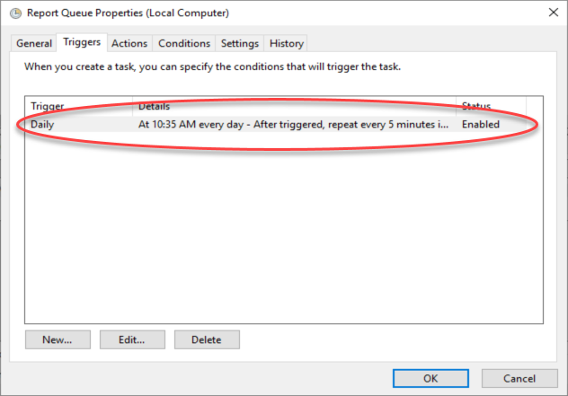  Figure 22: Open the Edit Triggers dialog… | 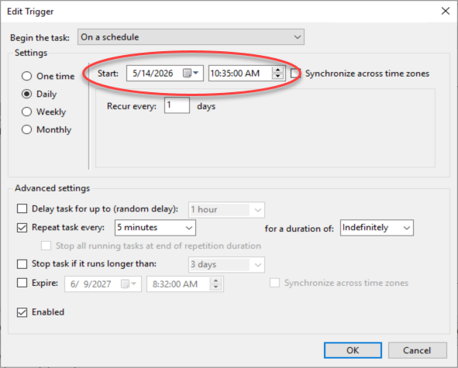  Figure 23: …and set the Start date and time to the future.
- Click the OK button in the Edit Trigger dialog box and then click the OK button in the Properties dialog box.
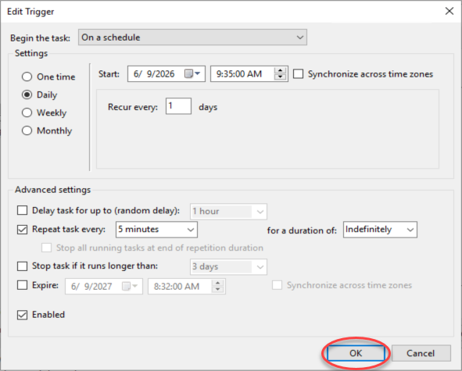  Figure 24: Save the trigger… | 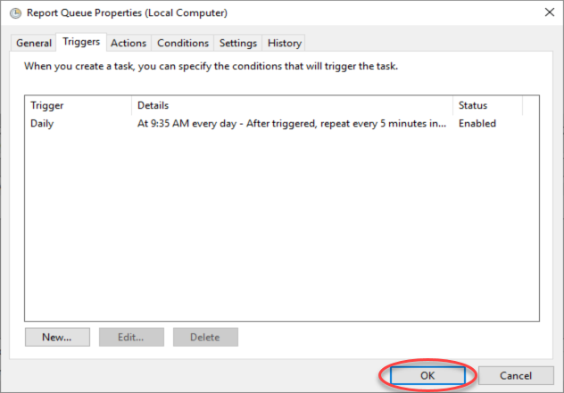  Figure 25: …and save the task.

Files
SQL used to get the SYSQUEUE records

